
Private Mail Bag
Ministries, Accra-Ghana Our Ref: NLC/TJ/KADA/6/26
Tel: 233-21 238737 / 238345 Your Ref: ________________________________
Fax: 233-21 238738 Date:6th June 2026

NATIONAL LABOUR COMMISSION
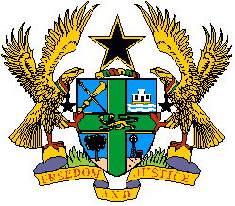
REPUBLIC OF GHANA

IMMEDIATE

THE CHAIRMAN
KOMFO ANOKYE DOCTORS’ ASSOCIATION (KADA)
P.O. BOX 1934
KUMASI

Email: kathkada@gmail.com

SUMMONS TO APPEAR BEFORE THE COMMISSION

IN THE MATTER OF DECLARATION OF STRIKE BY KOMFO ANOKYE DOCTORS’ ASSOCIATION (KADA)

The National Labour Commission has read in the media, a declaration of indefinite strike by Komfo Anokye Doctors’ Association (KADA), effective 6th June 2026.

The said declaration was communicated via a correspondence dated 5th June, 2026 addressed to the Chairman of the Board of Komfo Anokye Teaching Hospital and copied to the Chief of Staff and the Minister of Health among others. According to the notice, KADA is displeased with some operational and administrative decisions/actions and for these the Association has declared the industrial action.

KADA is advised that the notice was improperly served because it was not compliant with the relevant provisions of the Labour Law. Consequently, the Commission in exercise of its powers under section 139(d) of the Labour Act, 2003 (Act 651) directs KADA to call off the strike immediately as the action contravenes sections 162 and 163 of Act 651.

The parties are hereby summoned to appear before the Commission on Wednesday, 10th June, 2026 at 2pm for a hearing of the issues in dispute

PLEASE BE ACCORDINGLY ADVISED.

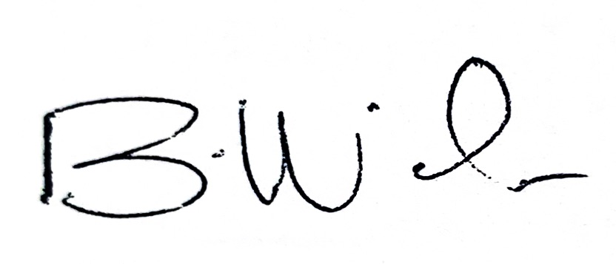

DR. BERNICE A. WELBECK
Ag. EXECUTIVE SECRETARY
For: COMMISSION

DISTRIBUTION

THE HON. MINISTER OF HEALTH, ACCRA

THE DIRECTOR-GENERAL, GHANA HEALTH SERVICE, ACCRA

THE PRESIDENT, GHANA MEDICAL ASSOCIATION, ACCRA

THE ASHANTI DIVISIONAL CHAIRMAN, GHANA MEDICAL ASSOCIATION

THE MEDICAL DIRECTOR, KOMFO ANOKYE TEACHING HOSPITAL

THE DIRECTOR OF ADMINISTRATION, KOMFO ANOKYE TEACHING HOSPITAL

Cc: The Chief of Staff, Jubilee House, Accra

The Secretary to the President, Jubilee House, Accra

