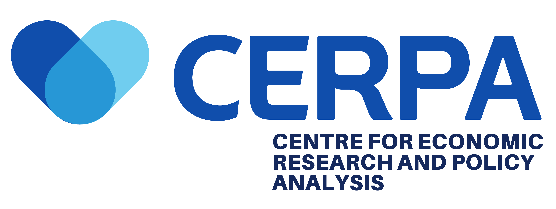

FOR IMMEDIATE RELEASE

Early Eurobond Settlement: A Positive Fiscal Signal, But Structural Reforms Remain Essential

1. Executive Summary
On July 2, 2026, the Government of Ghana fully settled a US$700 million Eurobond obligation ahead of schedule. This payment comprises of US$525.2 million in principal and US$174.8 million in interest, which brings Ghana’s total payments to Eurobond holders to US$2.1 billion since January 2025.
While this development signals the government’s commitment to prudent debt management and strengthens investor confidence, CERPA urges policymakers to view this achievement within the broader context of Ghana’s ongoing economic recovery programme. The early settlement must be complemented by aggressive structural reforms to safeguard long-term macroeconomic stability and debt sustainability.

2. Significance of the Early Settlement
The early Eurobond payment is a positive signal to international financial markets and demonstrates Ghana’s continued discipline in debt servicing post-restructuring. According to the Ministry of Finance, the payment was executed through planned financing arrangements without placing undue pressure on the country’s foreign exchange reserves.
Since Ghana’s Eurobond debt restructuring in October 2024 which saw 98 percent participation from bondholders, the government has maintained regular coupon payments. With this latest settlement, Ghana is now fully up to date on all scheduled Eurobond debt service obligations for 2025, with a total of US$1,409.06 million scheduled for 2026.
This development is expected to:
- Reduce Ghana’s outstanding external debt burden.
- Positively influence Ghana’s credit ratings trajectory.
- Support foreign exchange market stability.

3. Persistent Structural Challenges
Despite this milestone, CERPA cautions that underlying structural weaknesses continue to pose significant risks to Ghana’s economic stability. As highlighted in our recent policy brief “Beyond Headline Inflation: Emerging Structural Risks in Ghana’s Inflation Trends,” several warning signs remain:
Inflation Pressures: Ghana's inflation rate declined significantly from 23.8 percent in December 2024 to 3.2 percent in March 2026. However, inflation has shown signs of renewed upward pressure, increasing marginally to 3.4 percent in April before rising further to 5.3 percent in June 2026. Similarly, services inflation increased from 7.2 percent in March to 9.6 percent in May, before easing slightly to 9.4 percent in June. Imported inflation also shifted from deflation to positive inflation, rising to 0.5 percent in April, 0.9 percent in May, and 2.3 percent in June 2026. These trends suggest emerging inflationary pressures, particularly from the services and imported components of the consumer price index, which warrant close monitoring to safeguard recent gains in price stability.
Regional Disparities: Significant economic inequalities persist, with the Bono East Region recording deflation of negative 4.4 percent in June 2026 compared to inflation of 10.2 percent in the North East Region for the same period.
Fiscal Pressures: The Bank of Ghana’s tight monetary policies - while effective in controlling inflation - have contributed to substantial financial losses at the central bank, highlighting the difficult trade-off between price stability and fiscal health.
Commodity Dependence: Ghana remains exposed to external shocks, particularly in the gold and oil sectors, with geopolitical tensions in the Middle East creating both opportunities and risks for the economy.

4. Policy Recommendations
To sustain the gains demonstrated by the early Eurobond settlement, CERPA recommends the following:
a) Strengthen Fiscal Discipline
- Maintain or exceed the targeted primary surplus of 1.5 percent % of GDP through expenditure restraint and efficient revenue collection.
- Avoid excessive spending and broad subsidies that could reignite inflationary pressures and worsen public debt levels.
b) Accelerate Structural Reforms
- Prioritise investments in transport networks, irrigation systems, storage facilities, and logistics infrastructure to address supply bottlenecks and reduce distribution costs.
- Expand affordable housing programmes and reform rent policies to ease persistent cost pressures on households.
c) Boost Domestic Production and Industrialisation
- Accelerate industrialisation and import substitution efforts to reduce Ghana’s exposure to external shocks and imported inflation.
- Implement agricultural market reforms, including improving market coordination and investing in storage facilities to minimise post-harvest losses and stabilise food prices.

d) Diversify Export Markets and Strengthen Resilience
- Diversify gold export routes beyond Dubai and develop domestic gold refining capacity.
- Revitalise the Tema Oil Refinery and expand strategic petroleum reserves to reduce vulnerability to oil price shocks.
e) Address Regional Inequalities
- Implement targeted development strategies in underserved regions, particularly northern Ghana, to address widening economic disparities and improve market access, infrastructure, and industrial activity.

5. Conclusion
The early settlement of the US$700 million Eurobond obligation is a significant achievement that reflects the government’s commitment to fiscal discipline and macroeconomic stability. However, CERPA emphasises that this milestone alone does not guarantee long-term economic resilience.
Without coordinated reforms aimed at boosting productivity, strengthening supply chains, reducing regional inequalities, and expanding domestic production, Ghana’s hard-won gains could prove difficult to sustain. The government must seize this moment of positive market sentiment to deepen structural reforms and build a more resilient, inclusive economy that delivers broad-based prosperity for all Ghanaians.
The full policy brief is available HERE

About CERPA

The Center for Economic Research and Policy Analysis (CERPA) is an independent, non-partisan economic policy think tank dedicated to advancing evidence-based policymaking through rigorous research, data-driven analysis, and practical policy recommendations. CERPA works to strengthen economic decision-making and contribute to informed public discourse on Ghana’s development priorities.

Media Contact

Center for Economic Research and Policy Analysis (CERPA)

Email: info@cerpagh.org

Website: www.cerpagh.org

